# 

# 

# 

CSE 3330: Databases and File Structures  
Project Phase 2  
  
Jeff Hernandez, ID: 1002162250  
Patrick Williams, ID: 1002030029

Table of Contents

**Part 1: Relational Schema: 3**

**Part 2: “CREATE TABLE” Statements: 4**

**Part 2: Screenshots of outputs: 7**

1) SELECT * FROM contract; 7

2) SELECT * FROM customer; 8

3) SELECT * FROM employee; 9

4) SELECT * FROM feedback; 10

5) SELECT * FROM item; 11

6) SELECT * FROM orders; 12

7) SELECT * FROM order_item; 13

8) SELECT * FROM store; 14

9) SELECT * FROM store_customer; 15

10) SELECT * FROM store_item; 16

11) SELECT * FROM vendor; 17

12) SELECT * FROM vendor_item; 18

13) SELECT * FROM vendor_store; 19

**Part 3: SQL Questions 20**

Question 1 20

Question 2 21

Question 3 22

Question 4 23

Question 5 24

Question 6 25

Question 7 26

Question 8 27

Question 9 28

Question 10 29

Question 11 30

Question 12 31

Question 13 34

# 

# Part 1: Relational Schema:

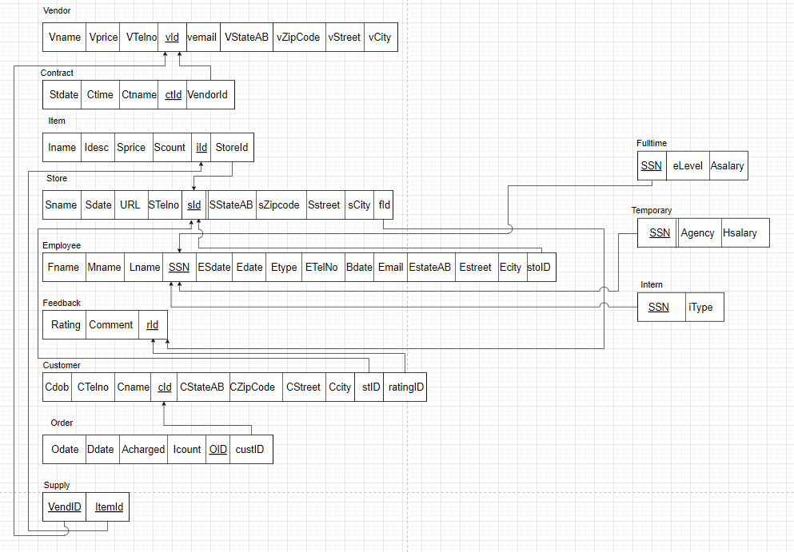

# 

# Part 2: “CREATE TABLE” Statements:

CREATE SCHEMA COMPANY;

CREATE TABLE COMPANY.STORE

(sID INT NOT NULL,

Sname VARCHAR(30) NOT NULL,

Street VARCHAR(25),

City VARCHAR(25),

StateAb VARCHAR(2),

ZipCode VARCHAR(11),

Sdate VARCHAR(10),

Telno DOUBLE NOT NULL,

URL VARCHAR(30),

PRIMARY KEY(sID) );

CREATE TABLE COMPANY.VENDOR

(vId INT NOT NULL,

Vname VARCHAR(15),

Street VARCHAR(25),

City VARCHAR(25),

StateAb VARCHAR(2),

ZipCode VARCHAR(11),

Vemail VARCHAR(30),

VTelNo DOUBLE,

PRIMARY KEY(vId) );

CREATE TABLE COMPANY.VENDOR_STORE

(vId INT NOT NULL,

sId INT NOT NULL,

PRIMARY KEY(vId, sId),

FOREIGN KEY(vId) REFERENCES VENDOR(vId),

FOREIGN KEY(sId) REFERENCES STORE(sId) );

CREATE TABLE COMPANY.CONTRACT

(vId INT NOT NULL,

ctId INT NOT NULL,

Sdate VARCHAR(10),

Ctime TIME,

Ctname VARCHAR(20),

PRIMARY KEY(vId, ctId),

FOREIGN KEY(vId) REFERENCES VENDOR(vId) );

CREATE TABLE COMPANY.ITEM

(iId INT NOT NULL,

Iname VARCHAR(15),

Sprice INT,

Idescription VARCHAR(64),

PRIMARY KEY(iId) );

CREATE TABLE COMPANY.VENDOR_ITEM

(vId INT NOT NULL,

iId INT NOT NULL,

Vprice int,

PRIMARY KEY (vId, iId),

FOREIGN KEY (vId) REFERENCES VENDOR(vId) );

CREATE TABLE COMPANY.ORDERS

(oId INT NOT NULL,

sId INT NOT NULL,

cId INT NOT NULL,

Odate VARCHAR(10),

Ddate VARCHAR(10),

Amount int,

PRIMARY KEY(oId, sId),

FOREIGN KEY(sId) REFERENCES STORE(sId) );

CREATE TABLE COMPANY.ORDER_ITEM

(oId INT NOT NULL,

sId INT NOT NULL,

iId INT NOT NULL,

Icount int,

PRIMARY KEY(oId, sId, iId),

FOREIGN KEY(oId) REFERENCES ORDERS(oId),

FOREIGN KEY(sId) REFERENCES STORE(sId),

FOREIGN KEY(iId) REFERENCES ITEM(iId) );

CREATE TABLE COMPANY.STORE_ITEM

(sId INT NOT NULL,

iId INT NOT NULL,

Scount int,

PRIMARY KEY(sId, iId),

FOREIGN KEY(sId) REFERENCES STORE(sId),

FOREIGN KEY(iId) REFERENCES ITEM(iId) );

CREATE TABLE COMPANY.CUSTOMER

(cId INT NOT NULL,

Cname VARCHAR(20),

Street VARCHAR(15),

City VARCHAR(15),

StateAb VARCHAR(2),

ZipCode VARCHAR(11),

CTelNo DOUBLE,

Cdob VARCHAR(10),

PRIMARY KEY(cId) );

CREATE TABLE COMPANY.STORE_CUSTOMER

(sId INT NOT NULL,

cId INT NOT NULL,

PRIMARY KEY(sId, cId),

FOREIGN KEY(sId) REFERENCES STORE(sId),

FOREIGN KEY(cId) REFERENCES CUSTOMER(cId) );

CREATE TABLE COMPANY.EMPLOYEE

(sId INT,

SSN CHAR(9) NOT NULL,

Ename VARCHAR(15),

Street VARCHAR(25),

City VARCHAR(25),

StateAb VARCHAR(2),

ZipCode VARCHAR(11),

Etype VARCHAR(15),

Bdate VARCHAR(10),

Sdate VARCHAR(10),

Edate VARCHAR(10),

eLevel VARCHAR(15),

Asalary DECIMAL(10,2),

Agency VARCHAR(15),

Hsalary DECIMAL(10,2),

INstitute VARCHAR(30),

Itype VARCHAR(15),

TelNo DOUBLE,

Email VARCHAR(30),

PRIMARY KEY(SSN) );

CREATE TABLE COMPANY.FEEDBACK

(cId INT NOT NULL,

rId INT NOT NULL,

rating INT,

Comments VARCHAR(100),

PRIMARY KEY(cId, rId),

FOREIGN KEY(cId) REFERENCES CUSTOMER(cId) );

# Part 2: Screenshots of outputs:

## 1) SELECT * FROM contract;

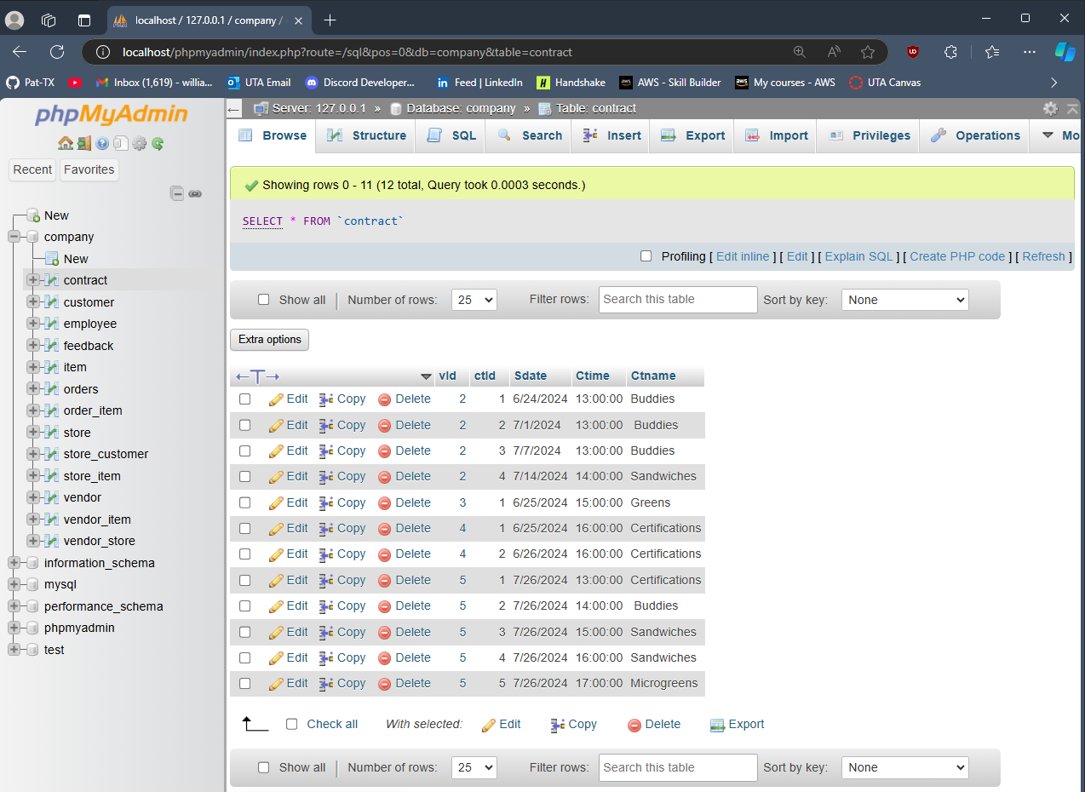

## 2) SELECT * FROM customer;

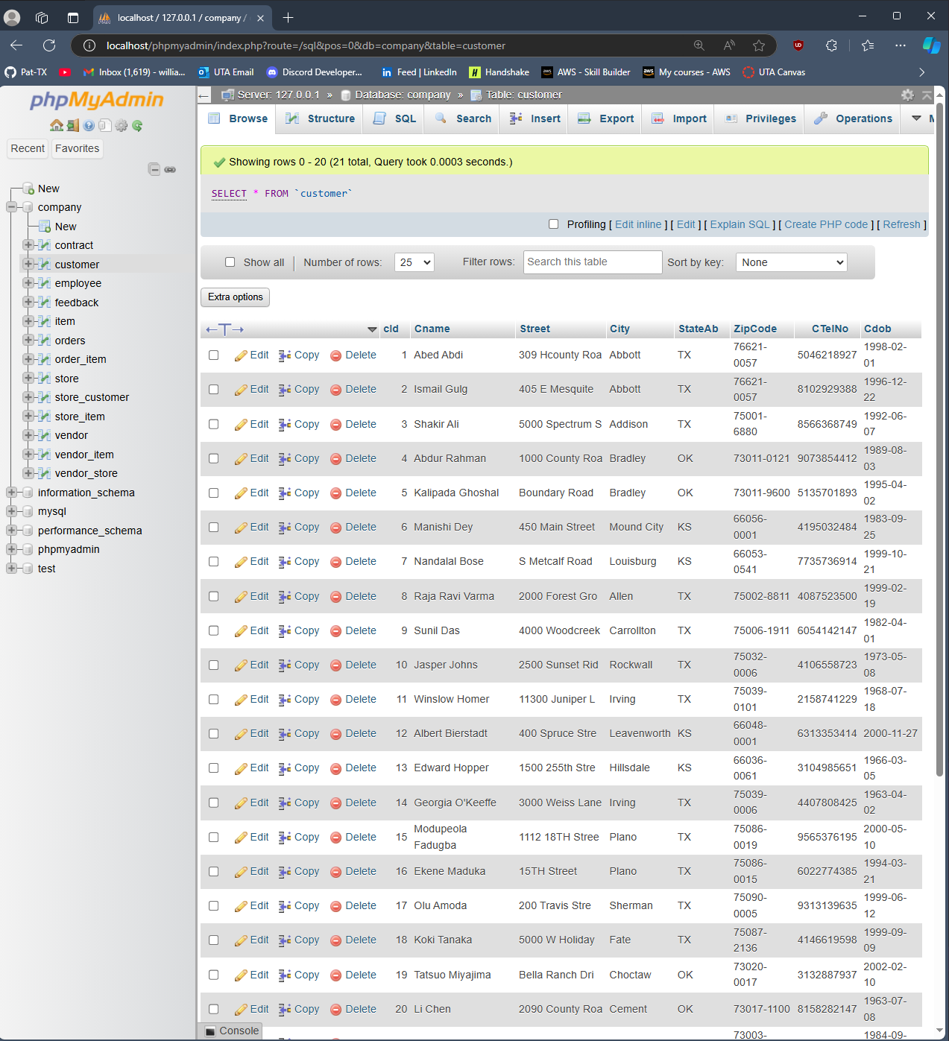

## 3) SELECT * FROM employee;

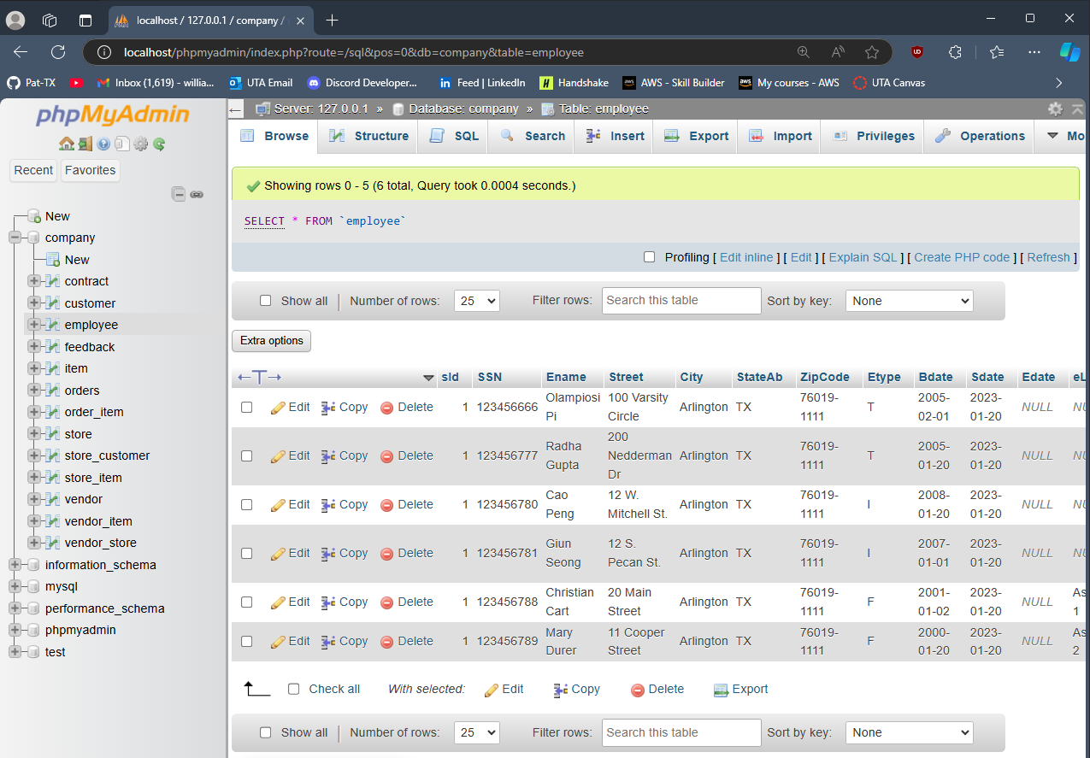

## 4) SELECT * FROM feedback;

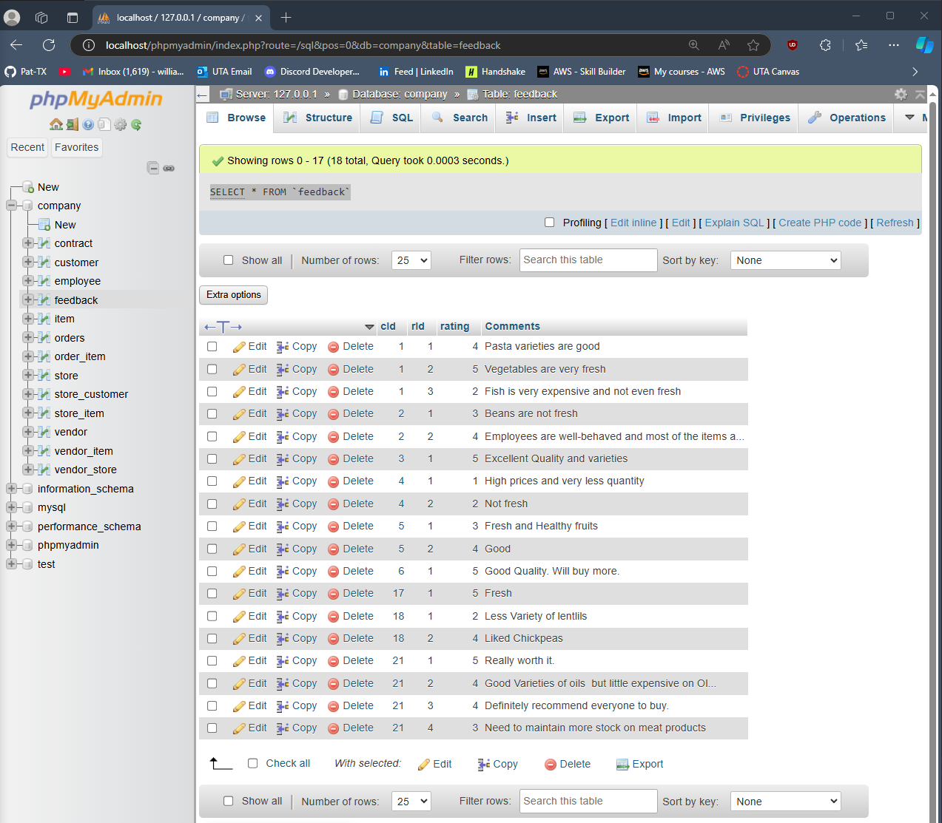

## 5) SELECT * FROM item;

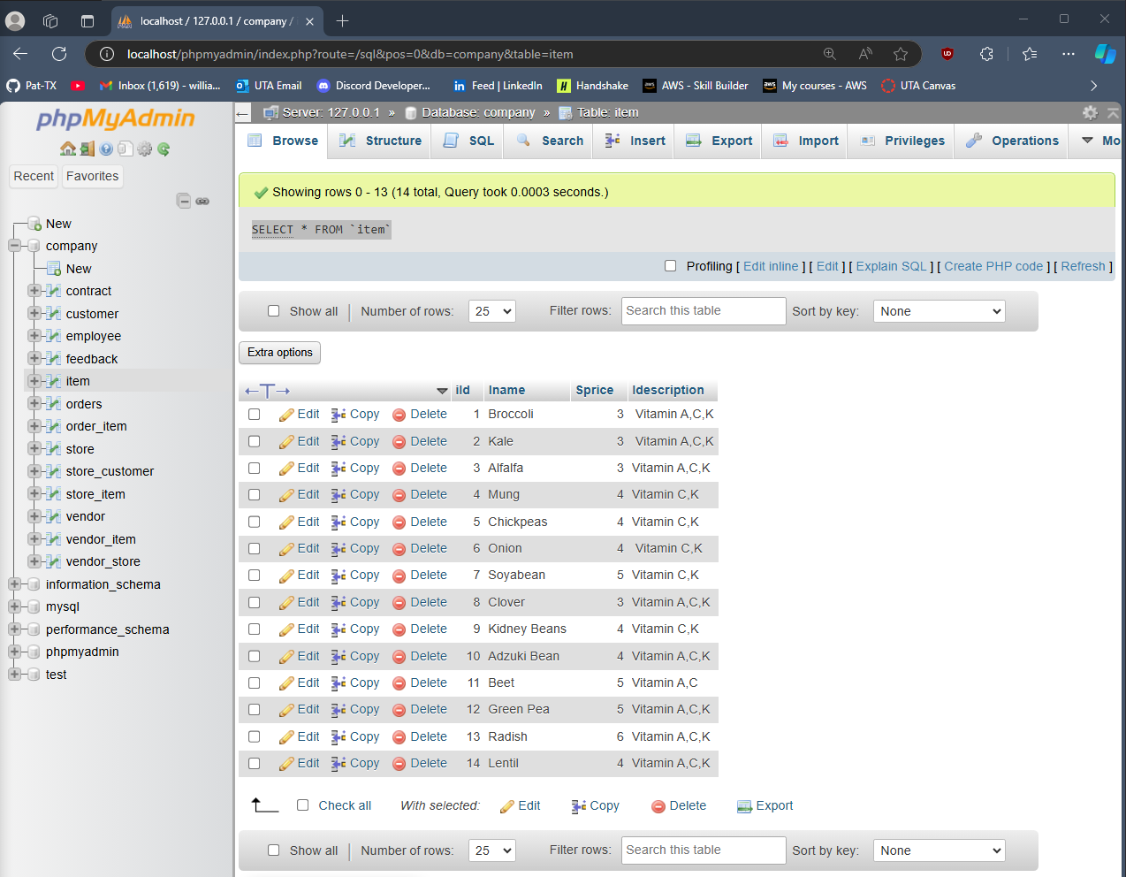

## 6) SELECT * FROM orders;

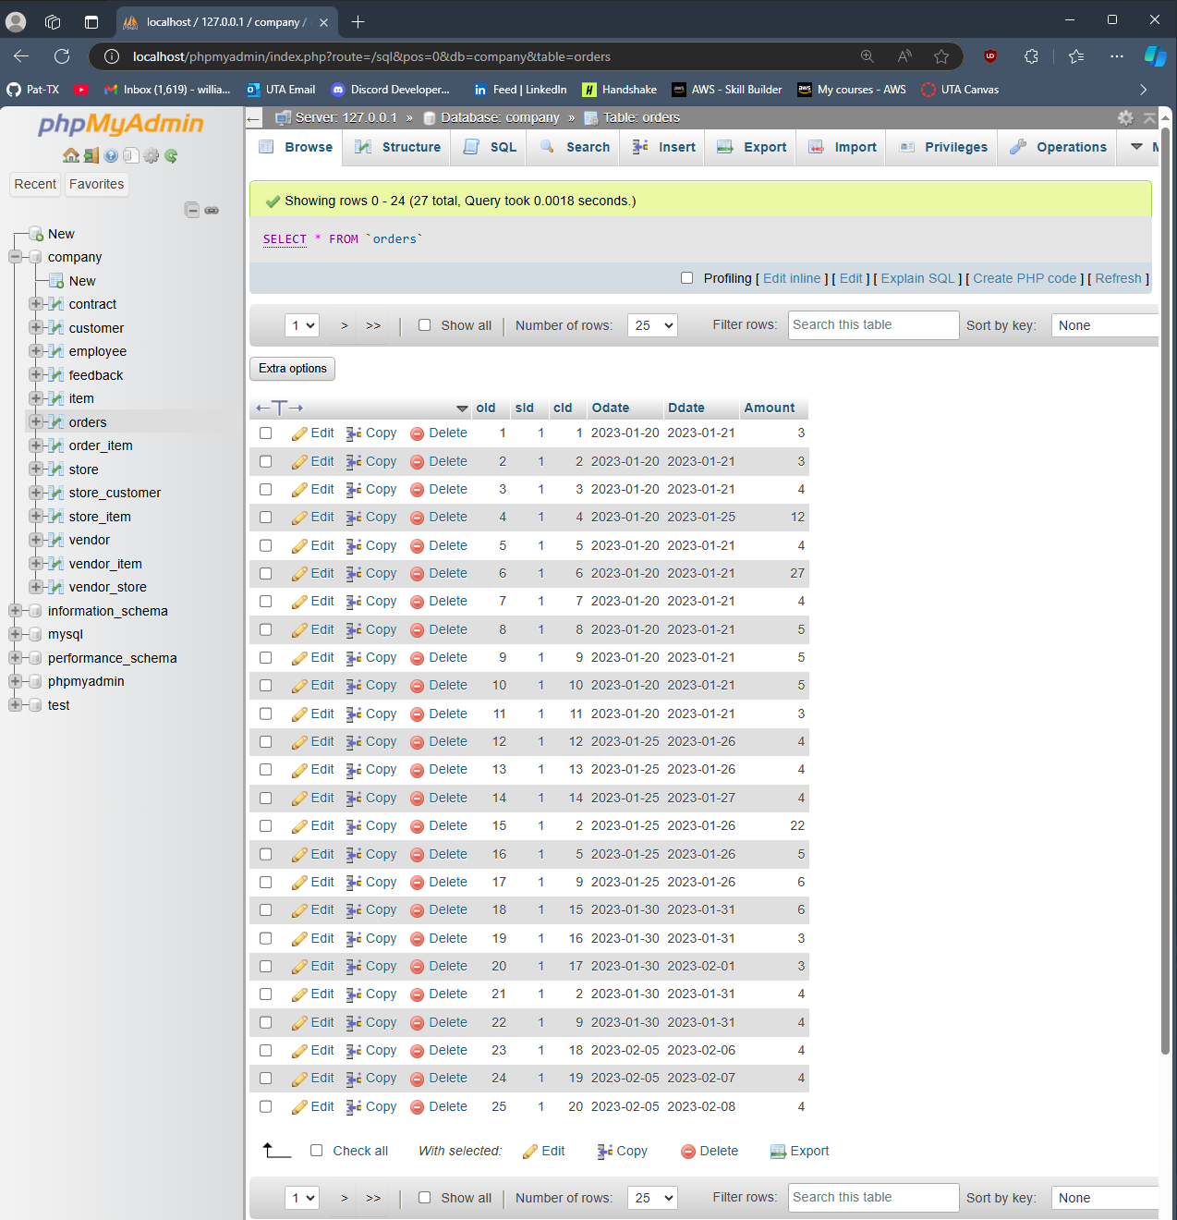

## 7) SELECT * FROM order_item;

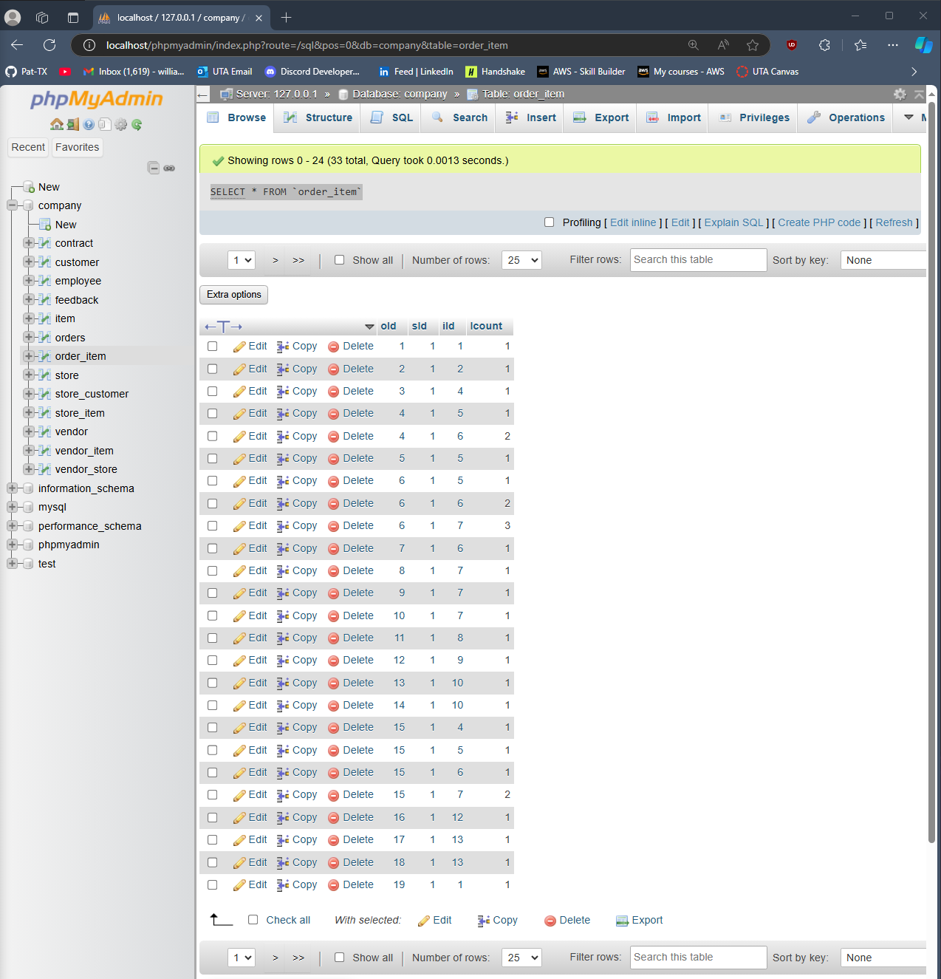

## 8) SELECT * FROM store;

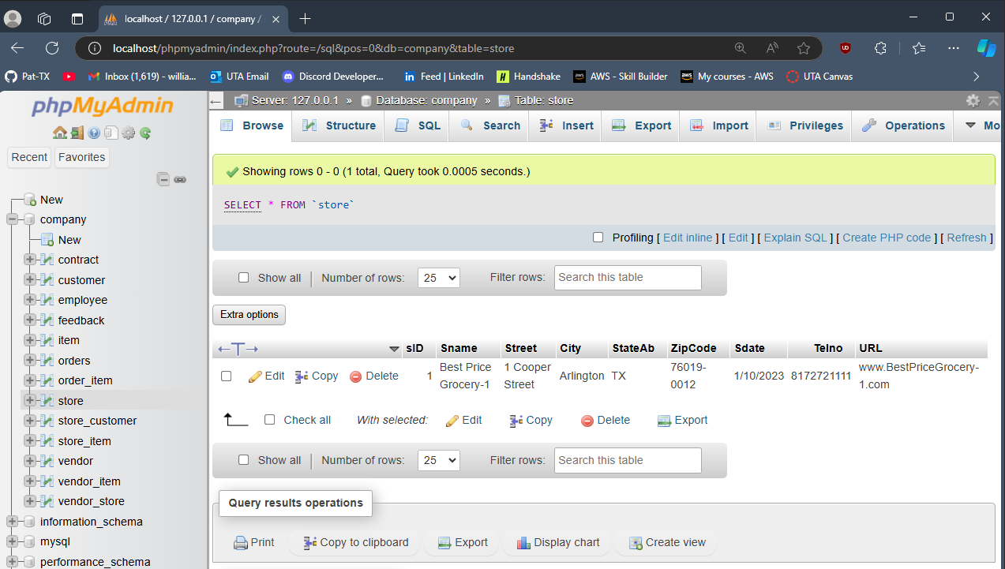

## 9) SELECT * FROM store_customer;

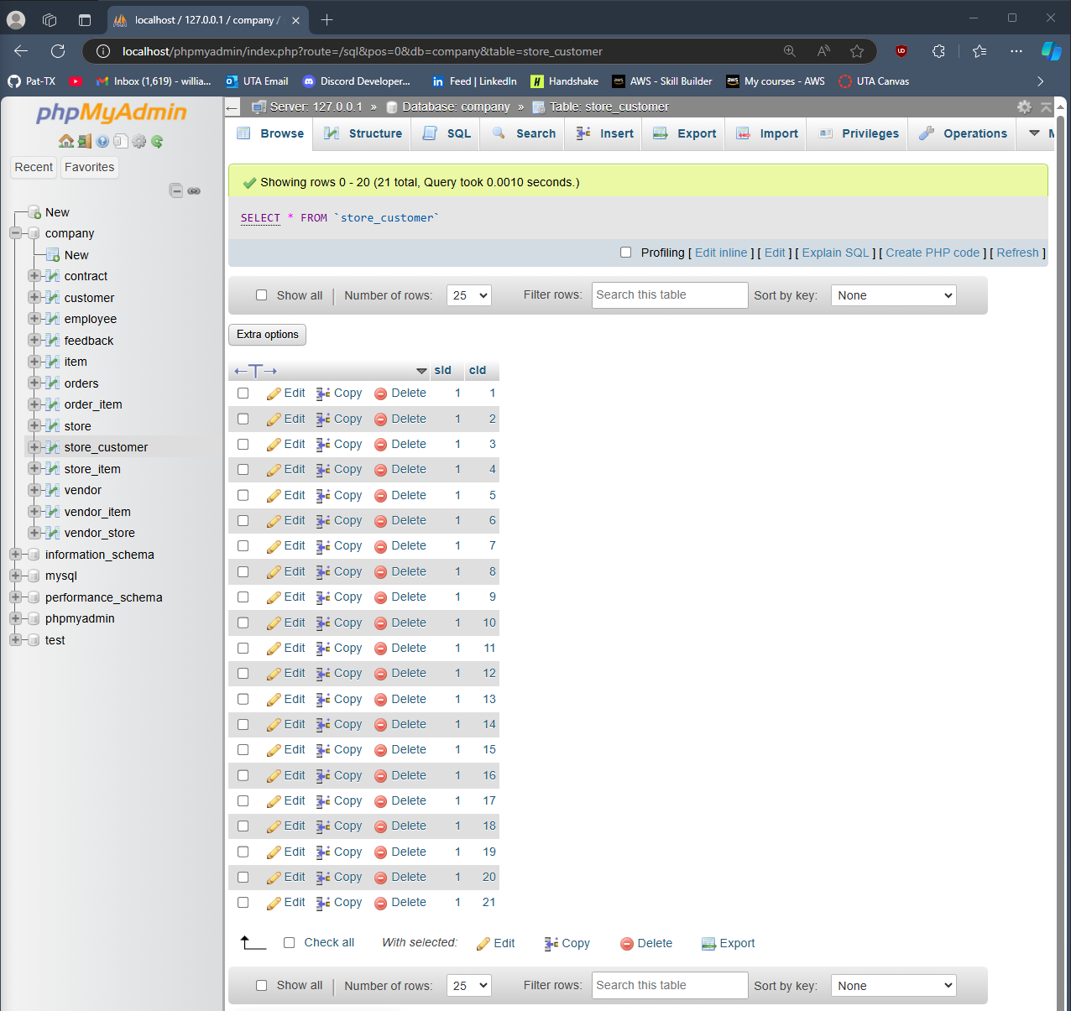

## 10) SELECT * FROM store_item;

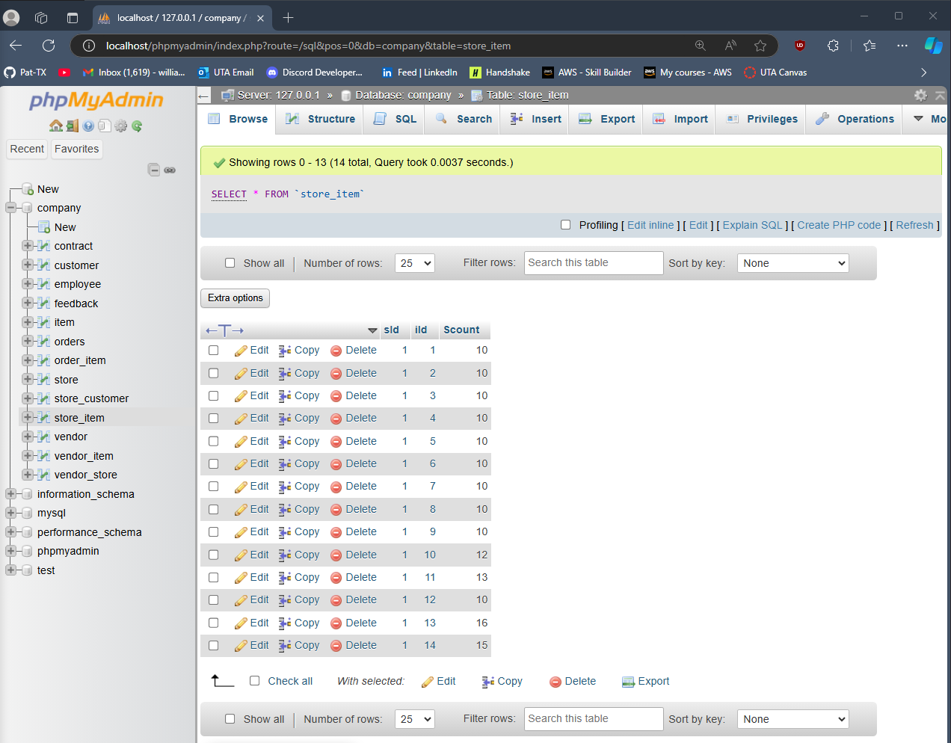

## 11) SELECT * FROM vendor;

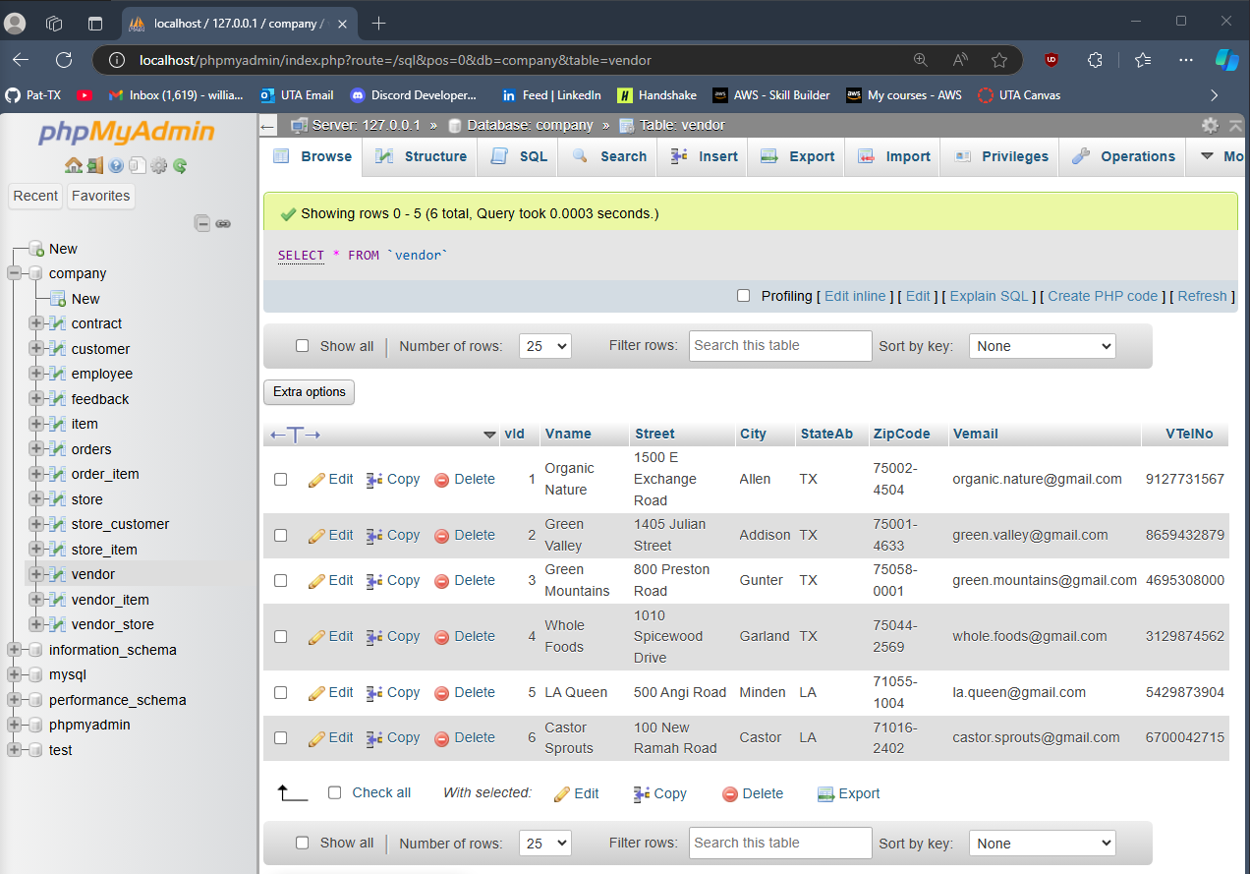

## 12) SELECT * FROM vendor_item;

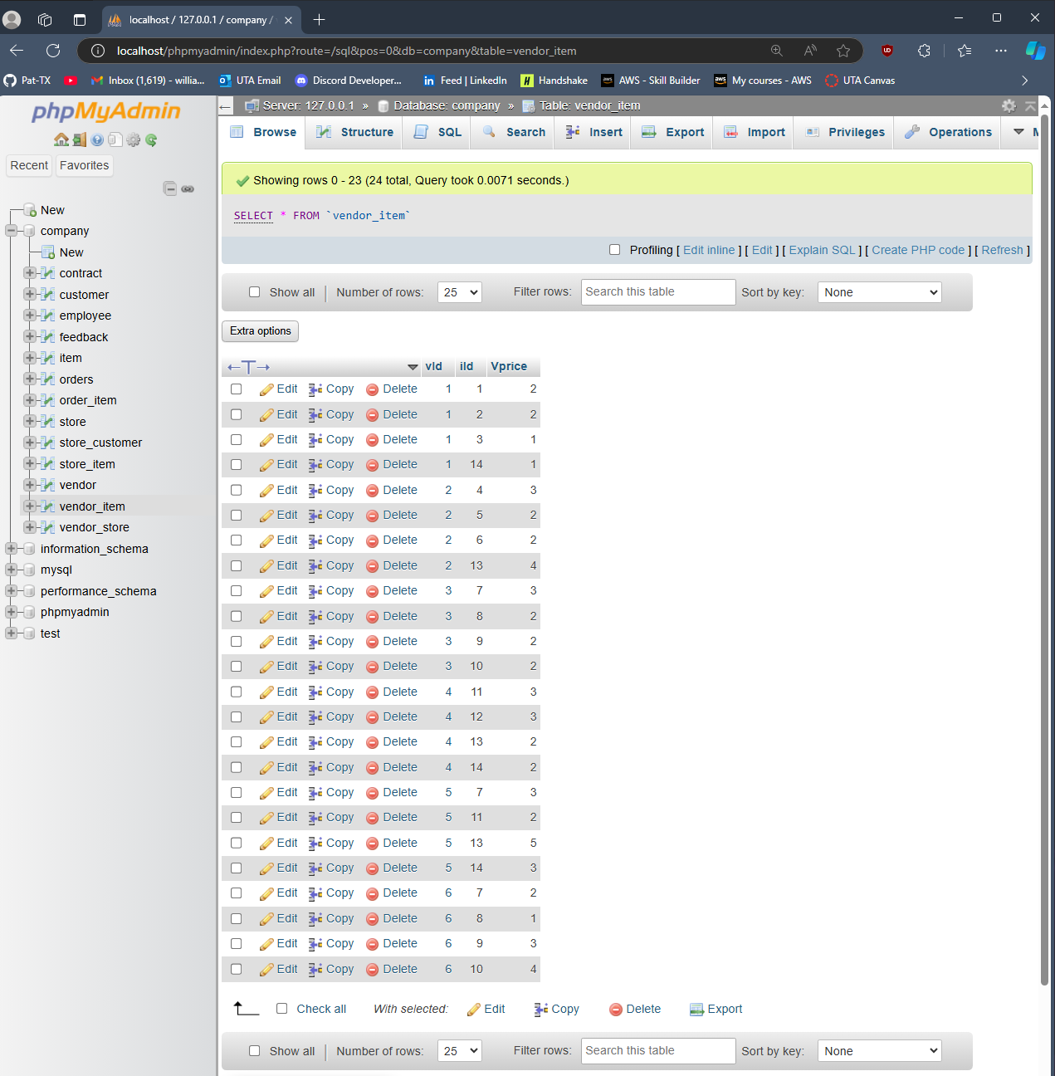

## 13) SELECT * FROM vendor_store;

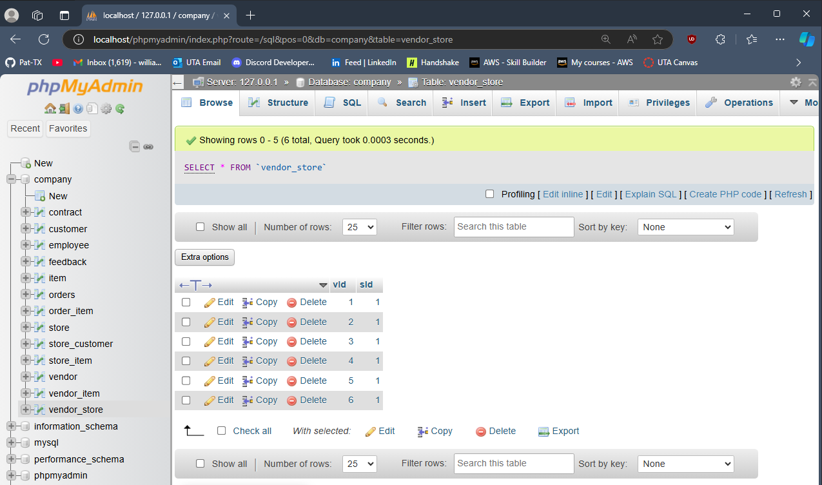

# Part 3: SQL Questions

## Question 1

SELECT Cname, Street, City, StateAB, ZipCode

FROM customer

WHERE Cname LIKE 'M%' OR Cname LIKE 'J%';

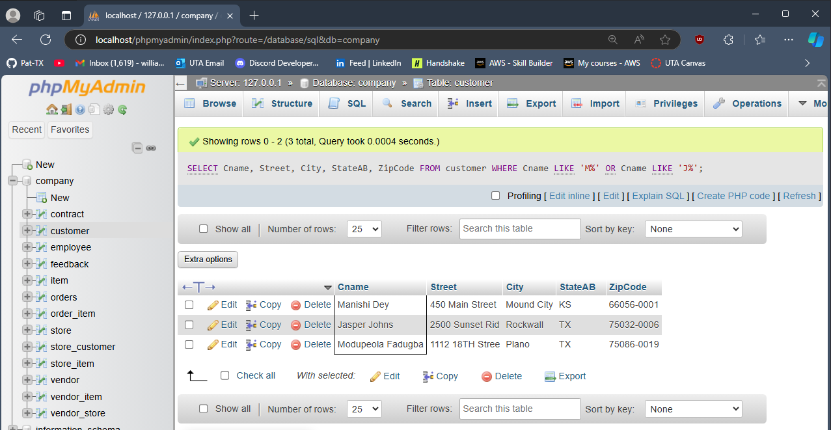

## 

## Question 2

SELECT Ename, Sdate, TelNo AS Telno

FROM employee

WHERE INSTITUTE = 'UTA' AND Etype = 'I';

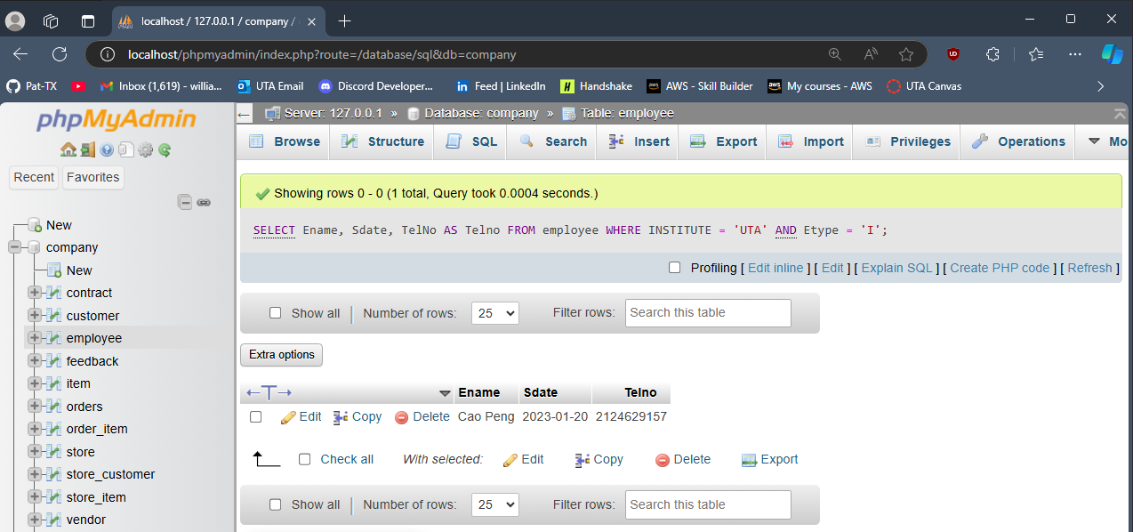

## 

## Question 3

SELECT C.Cname, CONCAT('$', FORMAT(SUM(O.Amount), 2)) AS TotalAmount

FROM CUSTOMER C

JOIN ORDERS O ON C.cId = O.cId

GROUP BY C.Cname

HAVING SUM(O.Amount) > 10;

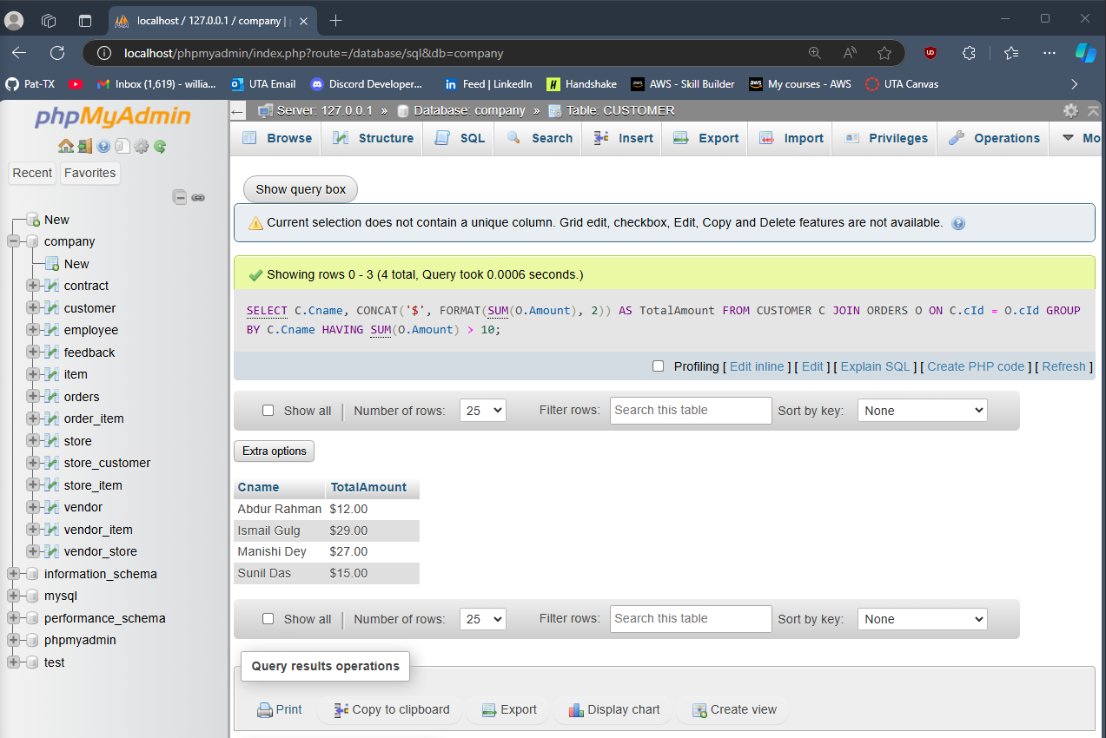

## 

## Question 4

SELECT Vname, City, Ctname

FROM vendor, contract

WHERE Sdate = '6/25/2024' AND contract.vId = vendor.vId;

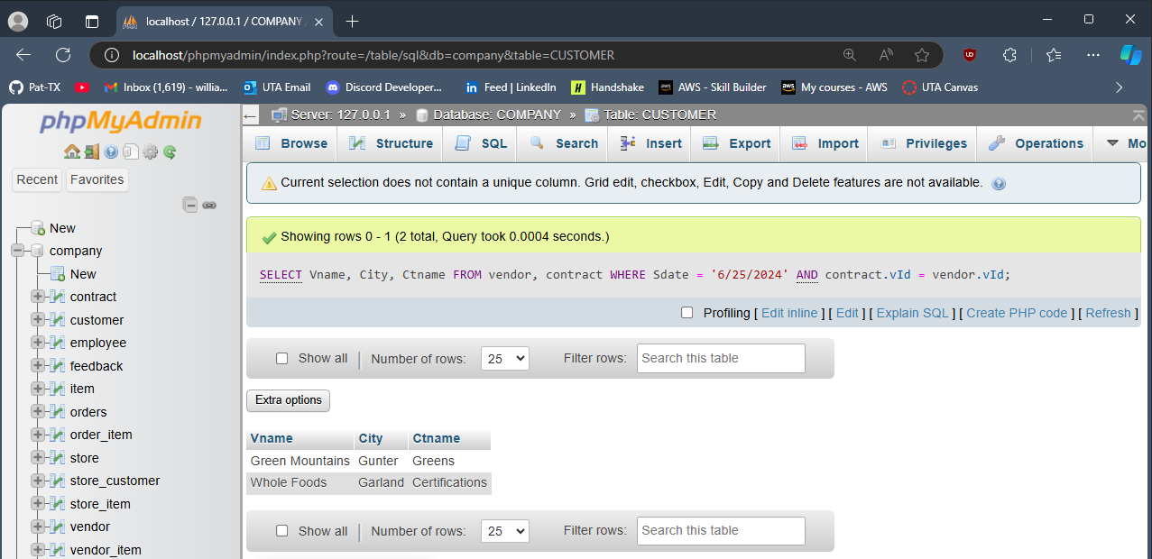

## 

## Question 5

SELECT Iname

FROM COMPANY.ITEM I

LEFT JOIN COMPANY.ORDER_ITEM OI ON I.iId = OI.iId

WHERE OI.iId IS NULL;

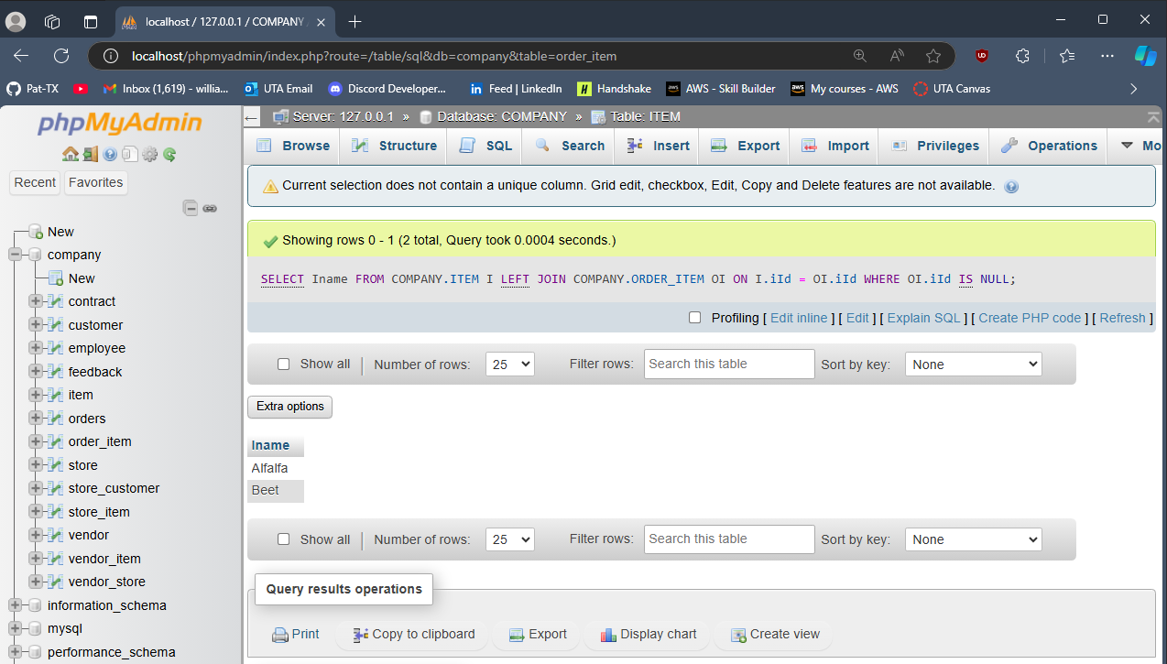

## 

## Question 6

SELECT Iname, SUM(Icount) AS TotalSold

FROM COMPANY.ITEM I

JOIN COMPANY.ORDER_ITEM OI ON I.iId = OI.iId

GROUP BY I.Iname

ORDER BY TotalSold DESC

LIMIT 5;

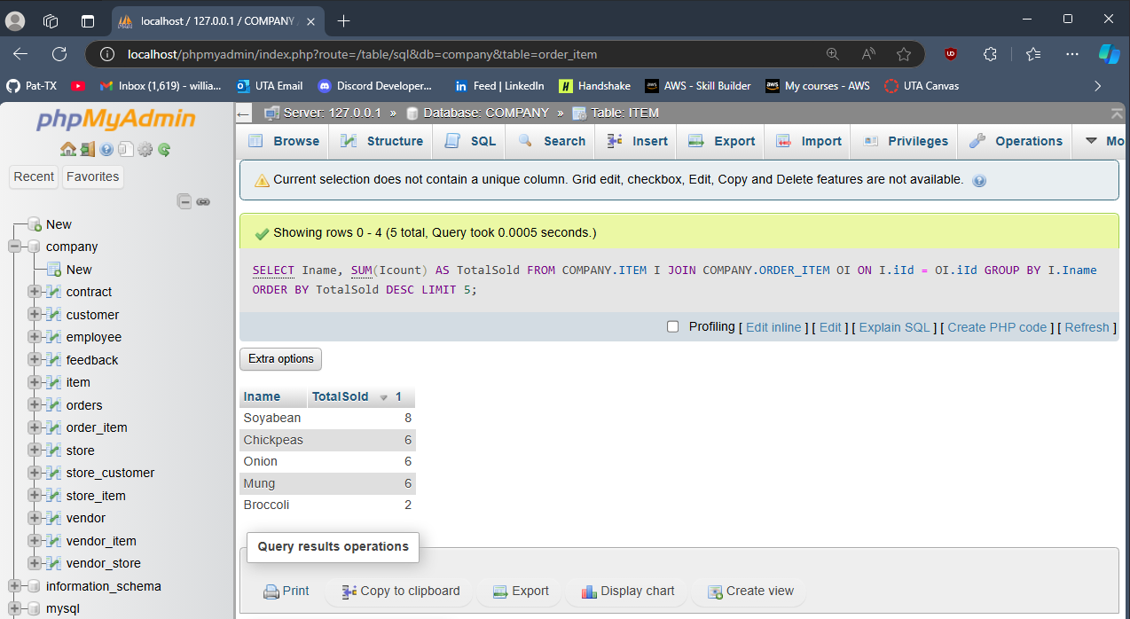

## 

## Question 7

SELECT DISTINCT C.cId, Cname, City, CTelNo

FROM COMPANY.CUSTOMER C

JOIN COMPANY.ORDERS O ON C.cId = O.cId

JOIN COMPANY.FEEDBACK F ON C.cId = F.cId;

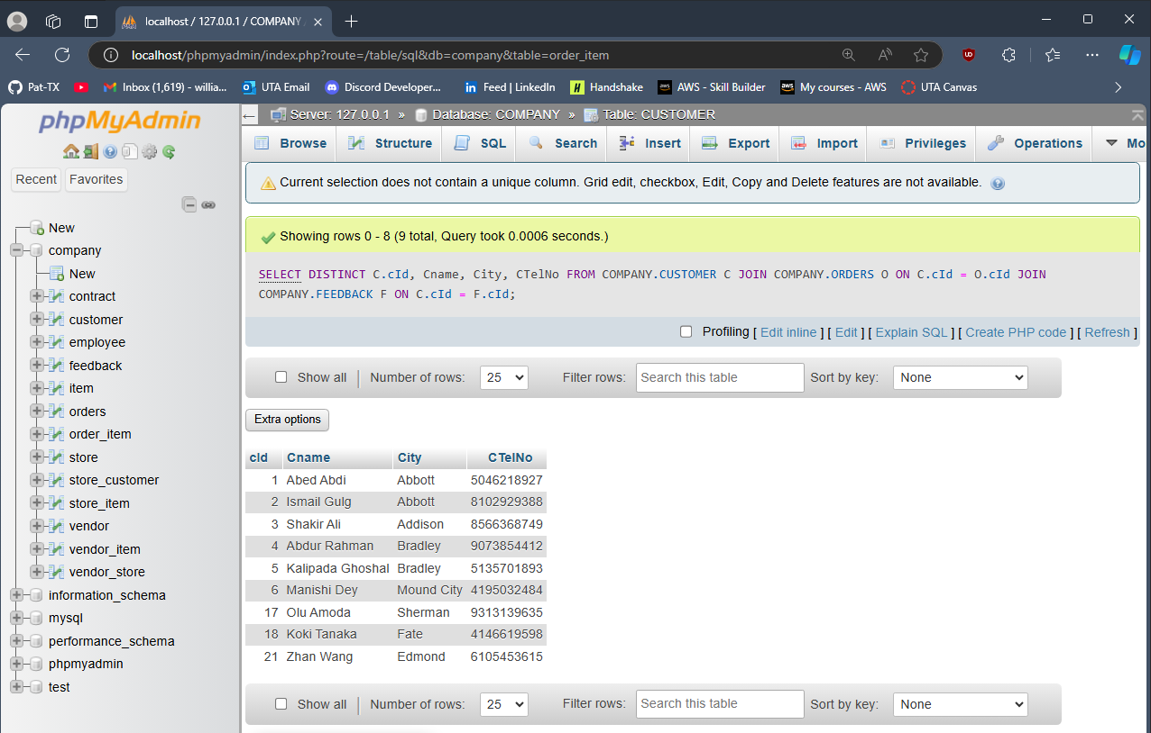

## 

## Question 8

SELECT MONTHNAME(STR_TO_DATE(Odate, '%Y-%m-%d')) AS OrderMonth, COUNT(*) AS OrderCount

FROM COMPANY.ORDERS

GROUP BY OrderMonth

ORDER BY OrderCount DESC

LIMIT 1;

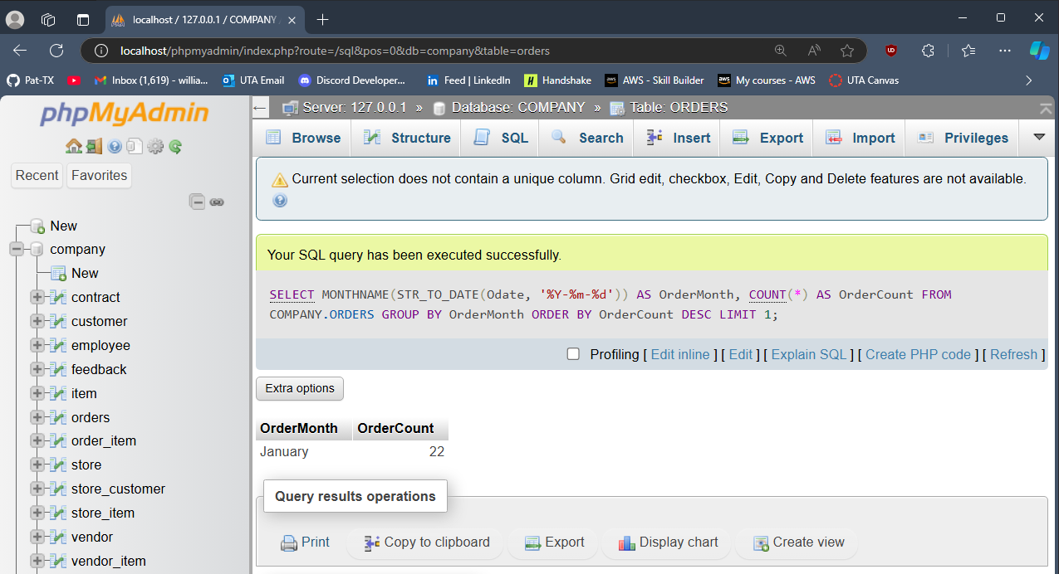

## 

## Question 9

SELECT CONCAT(ROUND(AVG(DATEDIFF(Ddate, Odate))) , ' days') AS AverageDeliveryTime

FROM COMPANY.ORDERS;

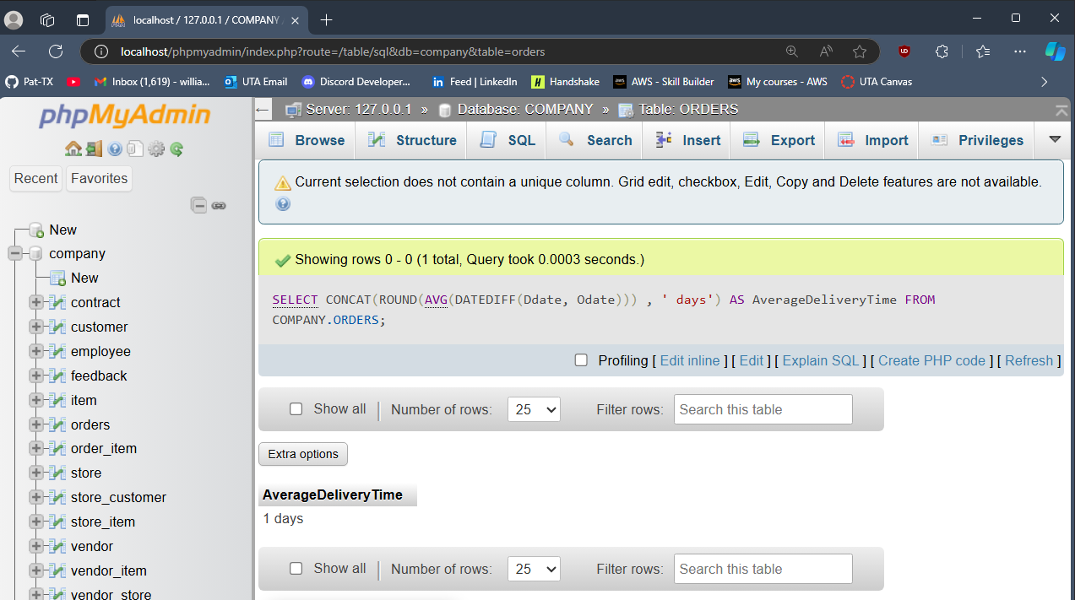

## 

## Question 10

SELECT Sname AS StoreName, City, SUM(Amount) AS TotalRevenue

FROM store, orders

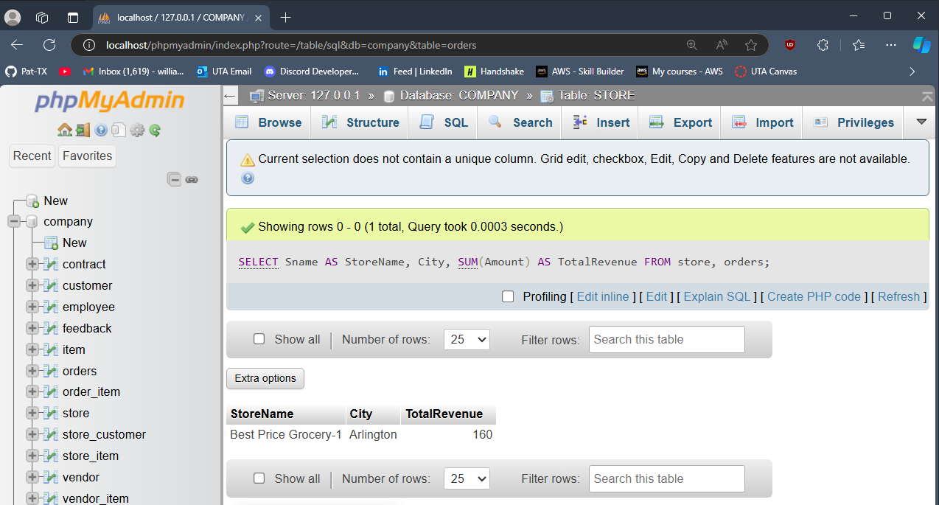

## 

## Question 11

DELETE FROM customer WHERE cId = 1;

Error message: “#1451 - Cannot delete or update a parent row: a foreign key constraint fails (`company`.`feedback`, CONSTRAINT `feedback_ibfk_1` FOREIGN KEY (`cId`) REFERENCES `customer` (`cId`))”

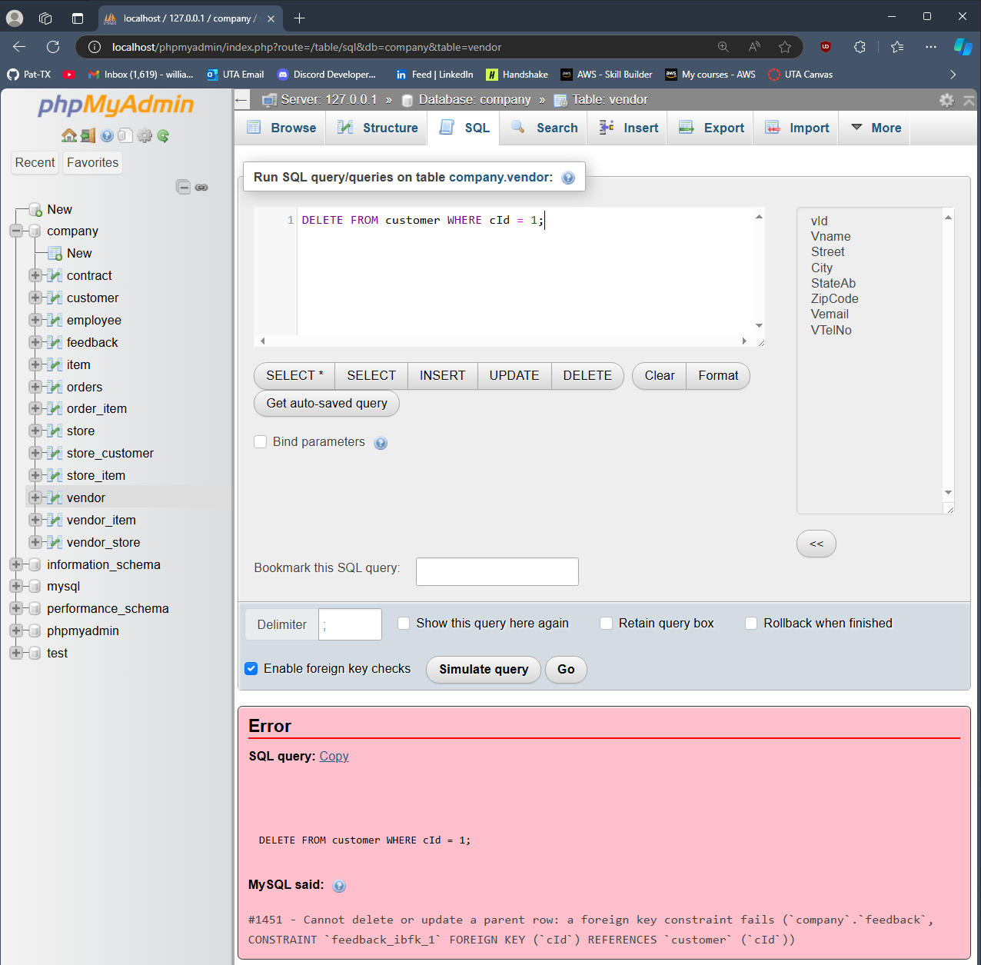

## 

## Question 12

**Key Constraint:**  
INSERT INTO customer VALUES ('1', 'Patrick', '123 Rose St.', 'Fort Worth', 'TX', '76179', '8125551247','02-20-2001')  
Error message: “#1062 - Duplicate entry '1' for key 'PRIMARY'”  
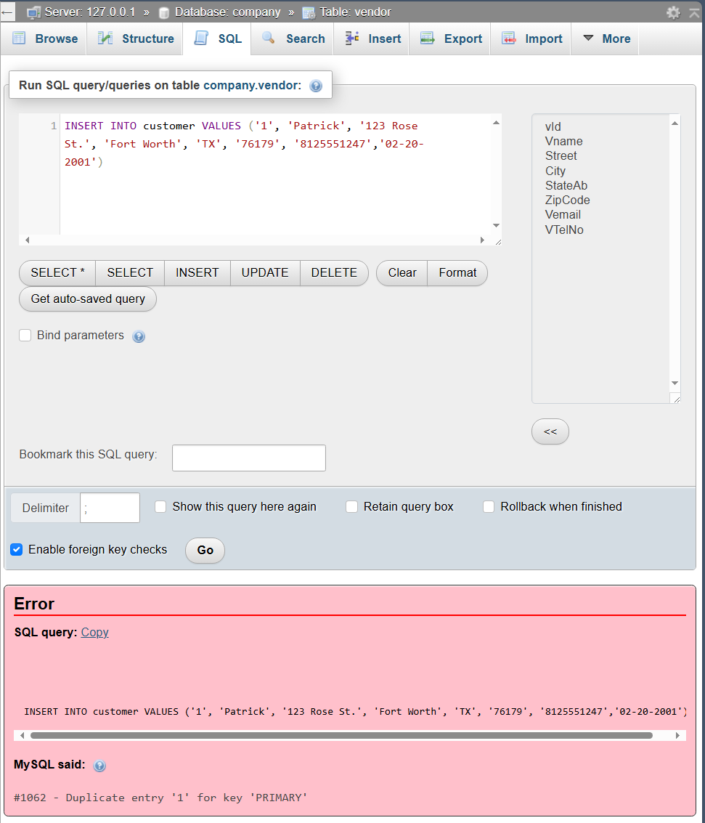

**Entity Integrity Constraint:**  
INSERT INTO vendor_store VALUES (NULL, '15');  
Error message: “#1048 - Column 'vId' cannot be null”

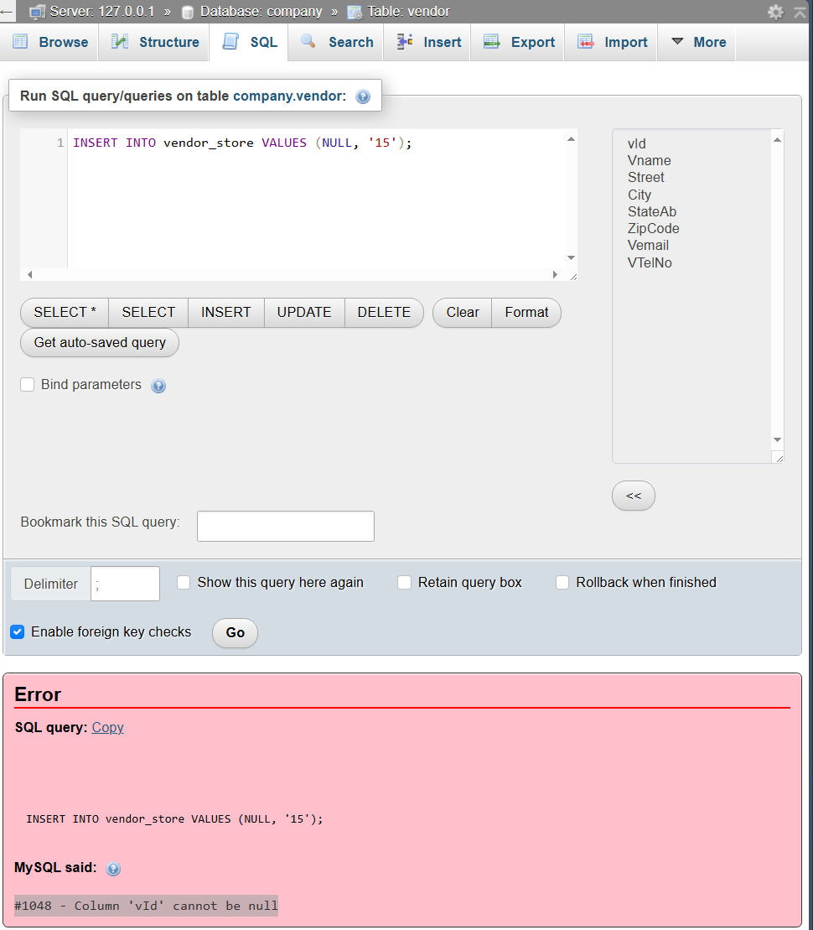

**Referential Integrity Constraint:**

INSERT INTO feedback VALUES ('9519','54', '5', 'Very good');  
Error message: “#1452 - Cannot add or update a child row: a foreign key constraint fails (`company`.`feedback`, CONSTRAINT `feedback_ibfk_1` FOREIGN KEY (`cId`) REFERENCES `customer` (`cId`))”

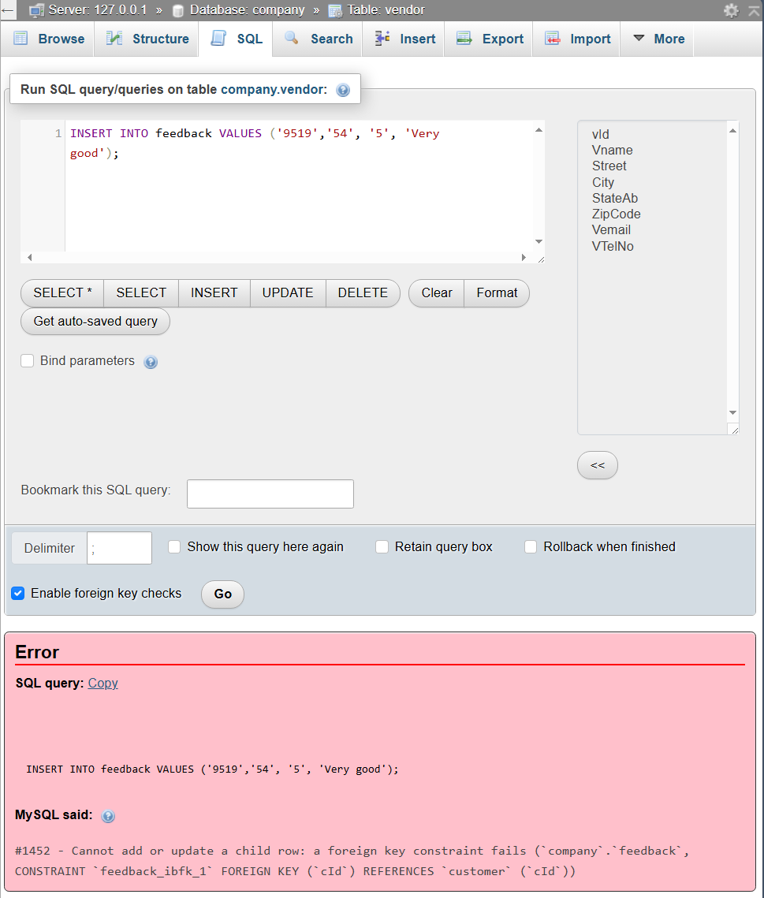

## Question 13

UPDATE vendor_store

SET vId = 99999

WHERE vId = 1 AND sId = 1;

Error message: “#1452 - Cannot add or update a child row: a foreign key constraint fails (`company`.`vendor_store`, CONSTRAINT `vendor_store_ibfk_1` FOREIGN KEY (`vId`) REFERENCES `vendor` (`vId`))”  
